Emergency Guide to Stabilize and Care for Found Orphaned Squirrels
JILL HORSTMANN·THURSDAY, AUGUST 23, 2018
If you are reading this guide it is likely the unthinkable has happened. You probably love animals in general, maybe squirrels specifically, but maybe not, and now you have found an animal in need. You are concerned and frightened and you have no idea what to do or when to do it. First, you need to calm down. Get the adrenaline out of your system, take some deep breaths and get yourself together, because if you don’t remain calm and collected, you will make mistakes that the baby or babies in your care, cannot afford for you to make. This guide is broken up into sections to help make it easy for you to use. First you need to go through Section 1 completely until you are prompted to go to Section 2. If you make it to section 2, no worries…you will get another pep talk because you will need it for what comes next. I will say now, and several times during this guide, experienced help is critical, so while it is great to be determined and confident, over-confidence has killed far too many babies. In addition, DO NOT post on social media or go to websites NOT recommended in this guide. We selected the most reputable, well respected sites and if they aren’t listed here, it is likely you don’t want to use them. Posting on social media is a disaster and you will likely get some good advice, but it will be buried in an avalanche of horrible advice. Go to experts!
DETERMINE IF THE BABY CAN BE REUNITED WITH ITS MOTHER
The first goal in “rescuing” a baby squirrel is to reunite it with its mother. If you know for certain the baby’s mother is dead or that the baby is injured, please skip to the This Baby Needs Help Section. If you are unsure please read on.
Step 1.
Determine if the baby is injured or ill:
-Is there signs of bruising?
-Are there broken bones?
-Open wounds, punctures?
-Bleeding from the nose, mouth, ears or genital region?
-Any sign of maggots, fly eggs, mites or other parasites?
-Does the baby appear to be dehydrated? (wrinkled skin or squirrel fails turgor test) see: http://squirrelrehabilitation.com/dehydration.htm
Step 2. Are there predators around? This includes ants or biting flies, cats, dogs, hawks, untrustworthy people or traffic in close proximity to the baby?
Step 3. How old is the baby?
-Does the squirrel have a fully fluffed up tail?
-Is it (excluding the tail) at least 6 inches long?
-Does it move quickly and strongly without any type of wobble or instability?
-Is it able to climb a tree or other vertical surface?
Step 4.
Determine the health and well being of the baby
-Are the baby’s eyes clear and free of discharge?
-Is the baby’s nose clear and free of discharge?
-Does the baby have a full coat (no missing patches of fur)?
-Is the skin in good condition (free of bumps, lumps and wounds)?
-Is the baby reasonably fearful of you if the eyes are open?
-Is the baby reasonably fearful of any companion animals or pets in the area?
-Does the baby appear to be a reasonable weight?
-Is the baby large enough and able to climb a tree to safety?
This is likely a juvenile baby that will be just fine! Please leave the baby be. If you are concerned about the baby’s location, gently usher it to a safer location. If there is a situation we didn’t cover, please use the resources included in this page and ask someone with experience. Even if you aren’t a usual FB user, it is worth it to establish an account and join the groups listed. Many of the groups have application questions in order to join, so look for that and make sure to answer fully and completely.
THE BABY NEEDS HELP
If you have gotten to this page, you have a critical and significant situation on your hands, with a baby that is depending on you not only making good decisions, but in remaining calm and collected and vigilant during every step of the process. I would tell you that your best option is always to get help from someone who is experienced. If you, for whatever reason, cannot get that help, it is critically important you follow each step exactly and that you invest in all of the needed supplies exactly. Any deviation can cause harm or even death to a baby. I encourage you to read through ALL of the sections and view all of the videos prior to doing anything beyond getting the baby warm, which is the first step, always. So follow the directions for getting baby warm, and while it is warming up, go through the remainder of the guide including all videos. By the time you are done, it will be time to start the tough stuff. Perhaps the most important thing you can do is remain calm. We understand you are someplace you have never been before, but if you follow directions and remain calm, chances are you and the baby will get through this with flying colors. So, with that in mind, let’s get the baby some much-needed help!
(Uninjured, No Parasites)
REUNITING BABY WITH MOM
If the baby is uninjured the first and foremost goal is to reunite it with its mother.
Neonates (pinkies, silkies, eyes closed): Immediate care is critical to the survival of these babies so you will need to act quickly.
If the mother IS alive or MAY BE alive and the baby is not injured, has no sign of external parasites, is not dangerously cold or in immediate danger from predators, try reuniting the baby. If you see the mother near or believe her to be near:
-Place the baby in a small box with basic nesting materials (fleece blanket shreds, flannel shirts) along with a sock full of uncooked rice that has been microwaved for 30 seconds, then shaken and pressed to evenly disburse the heat, if it is a colder climate. If it is an extremely warm climate, a t-shirt or other light fabric will work. Please note – do not use towel materials that can catch the baby’s nails and cause injury.
-Place the box with the baby in it at the base of the tree the nest was in, or if the tree has been cut down, at the base of the closest tree. If at all possible set a phone, speaker or other playing device at or very near the box and play baby squirrel cries to draw mom to the area. A good audio file can be found at: https://www.squirrelsandmore.com/pages/basic-steps-to-taking-care-of-a-baby-squirrel
-If possible wait, out of sight and silently near the box. If the mother isn’t back within 2-3 hours or if it is getting dark you will need to start on the next phases: Warm, Hydrate, Feed.
REUNITING HAS FAILED
Mom has not shown up or it is dark. It is time for action. The four basic steps are warm, (get experienced help if at all possible) hydrate and feed, IN THAT ORDER.
Step 1. Warm the Baby
Attend to the Immediate Needs of the Baby
-Warmth. Baby needs to be placed in a draft -free box with nesting material like fleece strips or flannel. Again, no fabric likely to catch on nails (towels). The box should be well away from any domestic pets or children.
-If you have a heating pad, put it on low under the box in such a way that the baby can scoot away from the heat (covering only ½ of the box)
-There are several options for a makeshift incubator, below is an image from Henry’s Health Pets. You can also use a small cat carrier and achieve a similar, but not exact result.
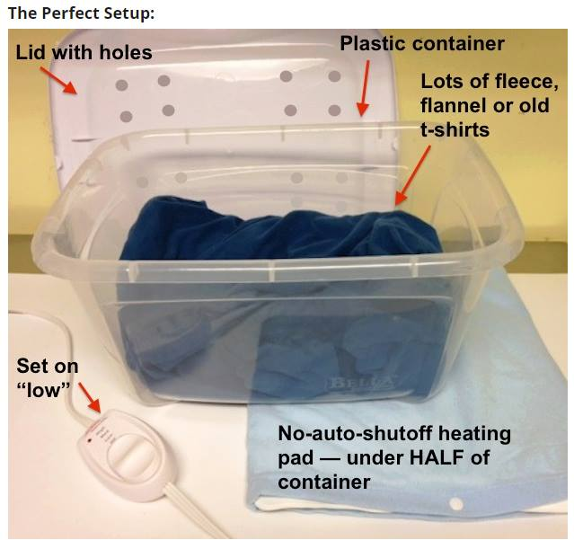
Perfect set up..
-If you do not have a heating pad, place the baby against your chest or abdomen gently and securely. Then work on a longer term heat alternative such as:
-Fill a sock with 1 cup of dry uncooked rice or dry beans and microwave for 30 seconds. Manipulate the sock after microwaving to disburse any “hot spots” that might have formed. Test by holding in your hand for 30-60 seconds. If it is uncomfortable for you to hold, it is too hot for baby. Place the sock next to the baby and cover him. Reheat every 2 hours and remember that babies CANNOT be left overnight without heat – so a heating pad is critical to their survival and the heating pad cannot auto-shut off or you will need to set an alarm to turn it back on as soon as it turns off.
-Do not move on to hydration until the baby has been completely warmed to be safe, that period should be 2 hours.
**Please note that cardboard boxes will dehydrate babies, so they should not be used unless there is no other option. If they are the ONLY option, fabric must be placed in such a way that the baby will not ever come into contact with the box.
At this juncture you need to make very quick and decisive decisions. The best option is to find an experienced rehabber with verifiable references and experience to take the baby. If you make that decision the following links will help you navigate to a rehabber near you. I would still encourage you to do a quick Google Search and look for reviews or feedback from anyone listed. You can also check the organization or individual’s reputation using Word of Mouth sites on Social Media or from your friends. If you are on Facebook, it is likely that someone you know either has experience, or knows someone with experience that can assist you. NEVER GIVE YOUR SQUIRREL TO ANYONE LOOKING FOR A PET OR THAT HAS NOT RAISED AND RELEASED MULTIPLE SQUIRRELS!
Rehabilitation Finder Links
At this point you need to read through the entirety of the remainder of the guide to make sure you understand and can commit both the time and money involved in caring for a squirrel in need. There is NO shame in realizing it is too much. Just by finding, stabilizing and bringing the baby to a rehabber, you are a wonderful, amazing and kind person! Be PROUD! Below will help you find a rehabber near you, or if you are on Facebook, reach out to the Closed Groups listed under the Resources Section of this guide, and let us network for you and get you the help you and baby deserve! Please remember it is both appreciated and appropriate to make whatever donation you can to the rehabber that takes your baby. Rehabbing is expensive and they need your help to continue their life-saving work!
https://ahnow.org/mobile/#/
http://m.humanesociety.org/animals/resources/tips/find-a-wildlife-rehabilitator.html
There is No Rehabber Available
Step 2. HYDRATION (tools before you get started)
A word of caution before going down this road, if you incorrectly hydrate a neonate, it is very likely a death sentence, so you need to be absolutely 100% sure that you have the skills, tools and the technique to appropriately and safely hydrate a baby prior to attempting it.
You will need the appropriate tools which include:
-1 cc syringe (if there is NO other option an eye dropper can work)**A local veterinarian or pharmacy or your family doctor can get you a syringe if you need one.
-Miracle Nipple (strongly preferred however if you don’t have one immediately available, it should be ordered and preferably overnighted or obtained within 24 hours)
-50 /50 solution of Pedialite/Distilled water OR (1/4 teaspoon salt, 1 ½ tablespoons sugar, 2 cups distilled water. Discard after 24 hours)
-Digital gram scale **Please note this isn’t optional, you cannot safely proceed with hydration or feeding until you know the baby’s weight in grams.
Please note hydration takes time. A truly dehydrated baby could take 8-12 hours to hydrate, however under no circumstances should the hydration period last longer than 12 hours.
Hydration Specifics
At this point, everything you do will either save the baby or will inadvertently harm it, so please read this section multiple times prior to attempting anything referenced. If you cannot get experienced assistance with the babies in your care, and need to hydrate them yourself, you must follow the instructions precisely. First the basic Do’s and Don’ts...
DO
-Keep the baby wrapped in fleece during the entirety of the time you are hydrating them.
-Go slowly! No matter how enthusiastically your baby wants to drink, if they aspirate they are likely to not make it or require immediate medical attention, so you need to go slowly and keep control of your syringe AT ALL TIMES.
-Give the appropriately calculated amount at the recommended interval.
-Warm the hydration mixture thoroughly by heating water in a cup, then dropping the syringe or container into that cup, shake or mix it to disburse heated liquid evenly.
-Hold the baby firmly in an upright position if they are young, older babies that can walk, can drink sitting up or lying on their stomach. (see images below)
-Keep hydrating until the baby’s skin isn’t wrinkly and the Turgur test indicates good hydration. Skin turgor test is used to estimate the extent of the dehydration in the baby. The measurement is done by pinching a portion of skin, on the back behind the neck, so that it is raised for a few seconds, then observing how long the skin takes to resume its normal position (flat). Hydration takes time, so expect this process to take anywhere from 4 hours to 8 hours with some extreme cases going longer. Video example of hydration and what dehydration looks like: https://www.youtube.com/watch?v=XjPMVq7Tq2g
DO NOT
-Use a bottle, nurser-bottle etc.
-Use tap water Attempt to hydrate in a distracted, loud or busy environment, you need to concentrate if you are new to nursing squirrels.
-Heat the hydration fluid in a microwave.
-Ever let a young or immature child nurse a baby squirrel.
-Overheat the water, it should be warm, never hot and always test it.
-Hold the syringe pointing down.
-Allow baby to nurse on its back.
-EVER begin feeding until the baby is completely hydrated.
-Forget to wash your hands thoroughly both before and after you handle the baby EVERY TIME.
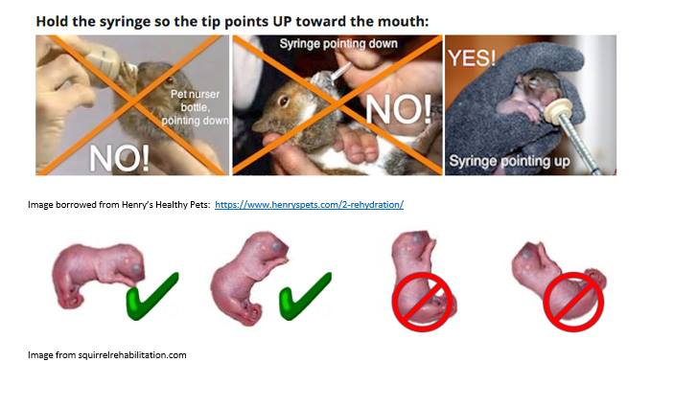
Do's and Don't..
Age/Size Percentage of Body Weight Frequency
Neonate (0- 2 weeks) 3% Offered hourly
Silverling (2.5 to 3 weeks) 3%-5% Offered every 2-3 hours
Infant Greyling (4 to 5 weeks) 5% Offered every 3-4 hours
Juvenile Greyling (5.5 to 7 weeks) 5%-7% Offered every 4-5 hours
Doing the math: (These amounts would be given in the intervals recommended based on weight and age (every 2 hours to 6 hours)
@ 3% ..... If squirrel weight is 35 grams x 3% = Calculator computation (35 x .03= 1.05 cc’s)
@ 5% ..... If squirrel weight is 75 grams x 5% = Calculator computation ( 75 x .05= 3.75 cc’s) @ 7% ..... If squirrel weight is 225 grams x 7% = Calculator computation (225 x .07 = 15.75 cc’s)
If you have some type of emergency and for whatever reason, cannot get to a digital gram scale to get an appropriate weight for a baby in need of immediate hydration, on a temporary, EMERGENCY ONLY basis you can use the chart below for the first few hours until you can get a gram scale. Remember this chart is based on Eastern Grey Squirrels, so Foxes and Flyers would need to be adjusted up and down accordingly.
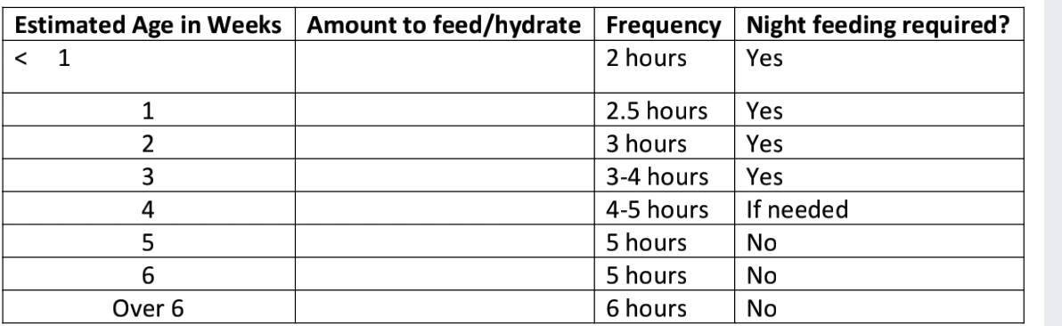
PLEASE NOTE – If you are not sure of the baby’s age, look carefully at the charts that follow, you need to know the species of squirrel in order to successfully determine its age.
These charts borrowed from The Arc http://www.arcforwildlife.com/squirrels.htm
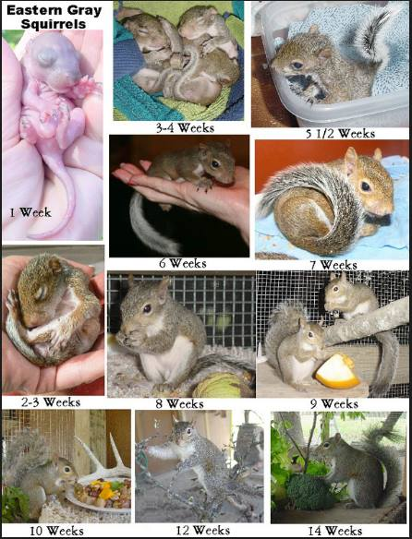

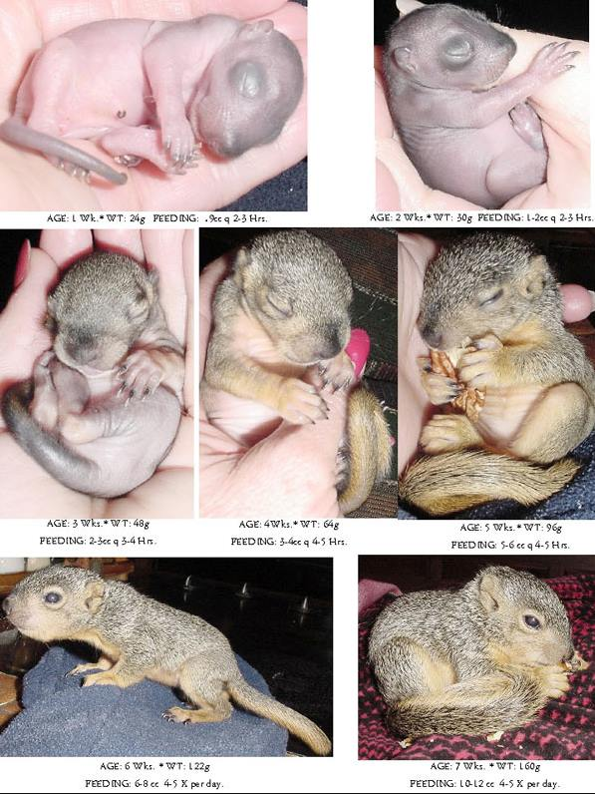

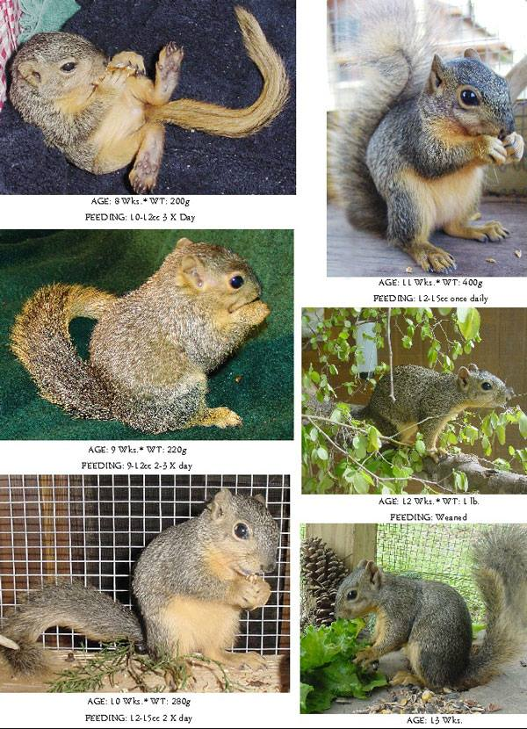

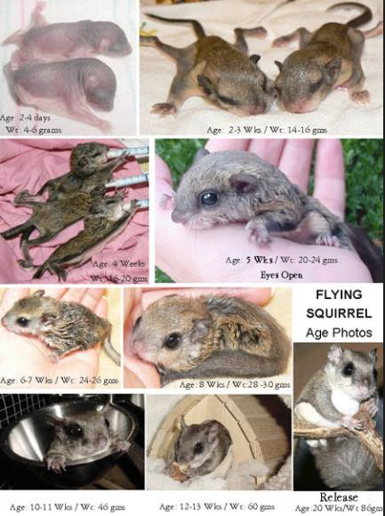
Feeding / Hydration Technique
Syringe feeding a baby squirrel is difficult and must be done properly to avoid tragedy. Baby squirrels are typically very aggressive nursers, this can include hydration as well. If they become over-eager or you depress the syringe faster than they can swallow, you risk aspiration. Aspiration is often deadly to baby squirrels, so your technique needs to be proper, and you must maintain a slow steady pace on the syringe. Always practice depressing the syringe with water several times, so that you know how much pressure it takes to push the liquid through. Additionally, you should invest in a proper feeding syringe, rather than what you may need to make due with initially. At the end of this guide is a vendor list to help you order the proper supplies you will need going forward if you aren’t able to find a rehabber. To see a baby being hydrated, view this video which will be helpful:
Video example of hydration and what dehydration looks like: https://www.youtube.com/watch?v=XjPMVq7Tq2g
The next two videos are of feeding formula rather than hydration, but will still provide you an outstanding look at how to handle and deal with holding and administering any syringe to a baby.
-PINKY- (please note I would use a Mini Miracle Nipple for this pinky, not the syringe in the video as you can see…it is HUGE) : https://www.youtube.com/watch?v=RiGU5YtLARY
-Silverling - https://www.youtube.com/watch?v=48NMfzPr4BY
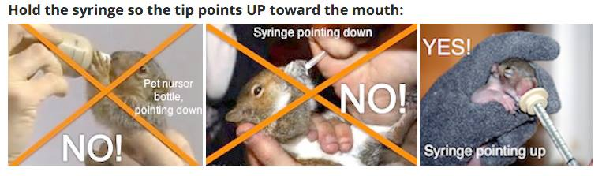
Image borrowed from Henry’s Healthy Pets: https://www.henryspets.com/2-rehydration/

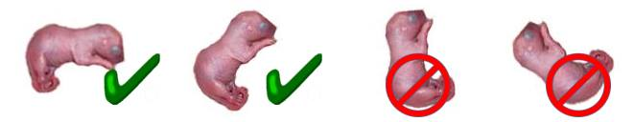
Image from squirrelrehabilitation.com
**Please note it is EASY to get bad form when feeding, your arm will raise and lower and adjust naturally from fatigue, especially feeding a pinky which takes, forever. Make a conscious effort to be aware of the baby’s position and your arm position at all times.
Hydration Steps
-Warm the hydration mix as directed in a cup of warmed water.
-Gently thump the syringe and get all air out of the top.
-Test the fluid in the syringe to make sure it is warm (not hot)
-Pick baby up, rapped in fleece blanket (warmth is critical)
-Gently put the syringe between baby’s lips on the side of the mouth and squeeze just a drop, wait for it to be swallowed.
-Repeat until the correct amount of hydration has been given based on the chart provided.
-GO SLOW
-If the baby inhales liquid, it comes out it’s nose or you hear coughing, immediately stop, tilt the baby upside down, then wipe baby’s face with a tissue, including the front of the nose and wait. Try again and go even more slowly. **Please note if your baby aspirates YOU MUST get in touch with a rehabber or veterinarian in case of aspiration pneumonia. If baby aspirates they could die within only a few hours, so you must act quickly.
-After appropriate hydration is given, it is time to potty! Typically you want to potty no longer than 30 minutes post hydration.
-As a general rule, you can consider baby fully hydrated when their urine is clear (as opposed to a very yellow or orange color indicating dehydration.)
Pottying
If your squirrel appears to be 5 weeks or less, in addition to hydration and formula feeding, you will need to stimulate them to poop and pee. You will need one or more of the following:
Materials (different materials will work better for different squirrels so experiment)
-Corner of a Kleenex
-Q-tip
-Warm Wet cotton ball
Timing – you will need to experiment to figure out what works best for YOUR squirrel
-Before feeding
-Mid feeding
-After feeding
Technique
Flick one of the above lightly and gently across the genital area of your baby. This stimulates the baby in much the same way that a mother’s tongue would in the wild. Generally, you would expect urine at every feeding, poop not less than every other feeding. Video Examples https://www.youtube.com/watch?v=fz9bEIjmOSA https://www.youtube.com/watch?v=3Or6VwE33Wk
FORMULA FEEDING Now that baby is hydrated and ready to eat, the next phase of your work proceeds. Again, I would encourage you to understand that baby squirrels need a knowledgeable hand for them to have the best chance of survival. Aspiration with hydration formula isn’t good, aspiration with formula is extraordinarily deadly and I would encourage you, to get the baby into the hands of someone with experience. At the end and beginning of this guide are resources. The FB groups listed at the end are full of willing and experienced rehabbers that can assist you in finding someone if you are not getting responses using the websites listed. If that isn’t possible, you must use extreme caution, follow directions precisely and continue looking for assistance, because if you make a mistake and aspirate baby, you will still need it. While baby squirrels are extremely easy to fall in love with, if you continue and want to see baby through to release, understand it is a year-long commitment and requires enormous amounts of financial and time resources, as well as logistical resources when it comes to releasing the baby. If you don’t live in an area where the baby can be safely released, I would encourage you to get it to someone who can do a “soft release” which is needed for the baby to have the best chance of survival.
FORMULA FEEDING
First and foremost, let’s talk about what you do NOT use as formula:
-KMR or any other kitten formula Any canned formula (this includes Esbilac, the recommended formula)
-Cow’s Milk
-Pet Lac
-Human baby formula
-Scalded Milk
-Goat’s milk (please note goat’s milk is recommended as an EMERGENCY substitute if the recommended formula is not available immediately (use3-5 days max)
Recommended Formula
There are two widely accepted formulas used by rehabbers. The first and most widely accepted is Esbilac Puppy Formula (with prebiotics and Probiotics ONLY) the second is Fox Valley. Given Fox Valley isn’t available locally and must be ordered, Esbilac is the formula you will be using initially. If you cannot get Esbilac locally we will include an EMERGENCY ONLY recipe for Goat’s Milk that will get you through the first several days if needed. But you will need to find and get Esbilac as quickly as possible, but without fail within 5 days. It is available at most farm stores, big box pet stores and online.
Transitioning to Formula Post – Hydration
Any transition, be it from Hydration protocol to formula protocol, or a change in formulas needs to be done slowly and carefully. Baby squirrels have extremely fragile digestive systems, and unforgiving digestive systems, so an improper transition can be deadly.
Formula Tips
-Transition slowly ANY time there is a change (change in formula, volume etc)
-Make the formula in small batches (24 hours worth at a time)
-Discard formula that has not been used after 24 hours
-Never give formula that has just been made, it needs to sit for 3-4 hours minimum prior to giving it.
-Never microwave formula, heat water and drop syringes or a small container into the water to heat it to just above body temperature
-Test the temperature on your wrist to ensure it isn’t too hot or cold
-Thoroughly clean both the syringes and formula bottles (highly recommend multiple sets of all of the above to ease the stress and burden of constant cleaning and sanitation)
-1 cc syringes are recommended for all inexperienced rehabbers, 3cc is widely accepted ONLY once babies have open eyes, under no circumstances use larger than a 5cc syringe no matter what the baby’s age is.
Starting Formula Feedings - Esbilac
After the baby is hydrated and you begin feeding formula, you will need to transition them slowly.
Pro tips for Feedings
For the first 3-4 feedings make the formula 3:1 water to formula instead of 2:1 which will be the normal dilution.
-Remember you must go slowly
-Use the smallest syringe appropriate based on age/weight/size
-Use or get a few Miracle Nipples as quickly as possible. If you are ordering Miracle Nipples get “Mini” for small babies along with the regular size for Junior Greylings and older. -Formula feedings will be at exactly the same intervals as your hydration schedule, and at exactly the same volume as well.
-Remember that you must weigh the baby every day, at the same time for the first 5 weeks, and adjust formula accordingly.
Calculate, the amount of formula twice to double check you aren’t over feeding.
-NEVER exceed 7% of total body weight.
-If your baby begins to lose weight you MUST get experienced help, something is wrong If you hear clicking sounds, see nasal discharge or your baby becomes lethargic you must get experienced help immediately.
-If your baby appears to get dehydrated you can continue to hydrate between feedings.
-Potty schedule should be followed exactly as it was for hydration.
-Always keep the baby warm during feedings.
Video of position for feeding and hydrating baby squirrel, remember to always use good techniques: https://www.youtube.com/watch?v=uYwwyfYVVMs

EMERGENCY GOAT’S MILK FORMULA UNTIL YOU GET ESBILAC OR FOX VALLEY (should not be used for more than a few days)
3 part goat’s milk
1 part plain yogurt
1 part heavy cream
If diarrhea occurs reduce or eliminate heavy cream for a few feedings and see if it resolves
---------------------------------------------------------------------------------------------------------
Common Problems While Nursing Baby Squirrels
Aspiration – It is extraordinarily important that you have control of the syringe every time you are feeding. Controlling the plunger will prevent babies from accidentally aspirating (inhaling formula). For aggressive eaters, put slight pressure on the plunger to slow down eating.
Refusing to Eat- There are three common reasons babies may refuse to eat
-Aspiration – listen for clicking, look for nasal discharge, lethargy. Get help/antibiotics immediately. Baby can die within hours depending on age.
-Teething – during teething, which occurs twice, you might see a touch of blood on the syringe, barring injury which should be ruled out, this is likely teething and should pass within a day
-Not accepting syringe- babies may initially refuse the syringe/formula simply because it will taste different and feel different than anything they have experienced. A Miracle Nipple will help, and time and persistence is critical, baby must eat.
-Baby isn’t warm – a cold baby will not eat. Make sure baby is warm and stays warm during feeding.
-Formula is no longer warm – cold formula is not only dangerous for baby, they likely will refuse to eat it, so double check the formula isn’t cold (or too hot) for baby to eat.
Feeding Trance –
When baby squirrels feed, they sometimes fall into what is commonly called a feeding trance. This is normal but can significantly slow down feeding because you cannot begin feeding them again until they are out of the trance. Sometimes you can gently blow on their face and it will snap them out of it. Keep them warm, wait it out and never ever begin feeding again until they are out of the trance.
To see a trance go here: https://www.youtube.com/watch?v=qJ6Pb-l2mpI
Bloating- bloating is typically caused by either over-feeding or feeding too frequently. After each feeding you will notice your baby’s stomach is well rounded, but it should still be soft and squishy to the touch. A hard belly (bloat) is problematic. Re-check your feeding calculation, reduce the percentage if appropriate, or slightly lengthen the times in between feedings. If bloat is particularly bad, you may need to skip a feeding and hydrate instead. No two squirrels are alike, so you will need to figure out what works for your baby specifically. Always make sure “bloat” isn’t actually constipation (baby should poop at a minimum of every other feeding and should urinate every feeding.)
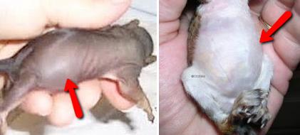
Image from Henry’s Pets Website
Constipation- Constipation is commonly seen when babies initially start on formula, obviously we cannot duplicate a female squirrel’s milk, so it is a shock to baby’s system to make due with puppy formula. Expect baby may not poop until after the first 24 hours on formula. Constipation can also be an indication that your baby is still dehydrated, so consider hydrating between feedings until the issue resolves. You can also try dipping the baby’s lower half into warm water and gently massage to get poop. ALWAYS dry baby completely.
Diarrhea- loose watery stools can be a deadly problem for baby squirrels. Loose stools can be caused by several different issues including, but not limited to:
-Parasites – certain parasites can cause loose stools. Be exceptionally concerned if the feces have a strong odor and are yellow and watery. This can be in indication of coccidia and must be treated immediately. You need to get experienced help immediately if treating for parasites is required.
-Over feeding – feeding babies too much can cause diarrhea please double check your feeding percentage and math to make sure you are feeding the correct amounts. One sign of over feeding is the appearance of white/chalky feces.
-Feeding too frequently – feeding babies too frequently can cause loose stools, so double check your frequency requirements based on age and weight.
-Transitional issues- transitioning babies from their mother’s milk to human-made formula can cause issues, so if loose stools occur in the immediate start of feeding formula, it should resolve quickly
-Benebac is a gooditem to order and have on hand – it supports good gut health in babies with diarrhea
**Note – additional hydration may be needed until loose stools are resolved. Keep a regular check on hydration and hydrate in between feedings if required. Remember loose stools can be deadly, so get experienced help immediately if they do not resolve. If you ask for help, make sure you take pictures of your baby, know its age and history and take pictures of the stools as well, this information will be critical in helping to diagnose the issue.
Genital Nursing – on it’s surface, genital nursing is, to the inexperienced, an amusing issue. Babies often nurse on the penis of males in the litter or can even nurse themselves. This can cause permanent damage to the penis and lead to life-threatening conditions. If you see swelling, redness or scabs forming on the end of the penis of male squirrels you must determine if it is sibling or self-genital nursing. Pro tips for dealing with genital nursing include:
-If it is sibling nursing, you may have to either remove the male being nursed on, or the offending sibling (if it is only one)
-Feed smaller portions more frequently. You may need to increase the frequency of your feedings, hungry babies nurse on genitals. Please note you do NOT exceed your feeding percentages under this scenario, but if you were feeding 5 cc’s every 2 hours, you might go to 2.5 cc’s hourly.
-Bag balm- sometimes applying a cream that makes the penis less palatable will work to curb nursing.
-Desitin, Boudreaux’s Butt Paste or other diaper treatments can sometimes help, but use caution as these tend to dry skin
-Bitter Apple – you can apply bitter apple, regularly to baby’s genitals and it may deter nursing.
-Outfitting baby in a children’s sock or physically blocking genital region from nursing may work but use extreme caution not to restrict baby’s ability to crawl towards and away from heat, and not to use anything that could wrap around fragile limbs and cut off circulation
** Always be extremely careful about what substance you use. First it cannot be toxic to squirrels, second it should not cause irritation to skin or burn the tip of the penis opening in any way. Don’t inadvertently use something to treat scabs that is tasty to nursing babies (this might be the case with Aloe). Generally, no petroleum-based products are recommended for use.
Hypoglycemia – just as feeding too close causes issues, if you space feedings too far apart it can result in frightening issues as well. Signs of hypoglycemia include:
-Gasping for breath
-Arching back Lethargy
-Crying / vocalizing
** Immediately rub organic honey, molasses or even pancake syrup on baby’s gums. You should see results in no longer than 30 minutes. Feed smaller amounts with increased frequency sticking to the correct amount and percentages calculated by weight and age.
Weaning
First – do not “wean” squirrels, as long as your baby will take formula you should give it. Formula is nutritious, provides calcium and other much-needed minerals for good growth. At six weeks old, you should introduce babies to solid foods. This introduction is critical and can, if not done properly, greatly impact your squirrel’s health and well being prior to release.
At six weeks old, you should begin to introduce your baby to solid foods and they should have shallow, spill-proof bowls of water available at all times (I would encourage you to have multiple bowls available as rowdy babies love to tip bowls over):
Recommended food characteristics:
-Foods that are low in phosphorus and high in calcium (generally you are looking for foods that have two parts calcium to 1part phosphorus. A list of ratios can be found online, here is one good site: https://www.thespruce.com/calcium-phosphorous-ratios-in-fruits-and-vegetables-1239498
-Foods that are not high in sugar
-Leafy greens (not spinach)
-A list of recommendedfoods can be found at: https://www.henryspets.com/healthy-diet-for-pet-squirrels/
-NEVER introduce nuts to your squirrel until they are consistently and happily eating leafy greats and appropriate vegetables in a robust way. When you introduce nuts they should be IN THE SHELL and be given after greens and veggies have been consumed (veggies early, nuts in the evening only and limited in quantity)
-Once babies are eating veggies in a good quantity and regularly, you can reduce formula feedings slowly to twice a day (morning and evening) until formula is refused for several days in a row.
-Get UNBLEACHED, UNTREATED antlers for babies to chew on, as this is the time teeth grow and need to be worn down. This provides additional calcium as well.
**Wild foods – It is around this time many people make the mistake of providing their squirrels acorns. While acorns are a natural food for squirrels, they can also be deadly. Acorns and peanuts grow a deadly fungus called aflatoxin which can kill squirrels in a matter of hours. Generally, it isn’t worth the risk. If you insist on providing acorns to your squirrel follow the following protocol for ALL acorns – absolutely NO EXCEPTIONS
-Acorns must be removed from the tree – NEVER collected from the ground
-NO holes, cracks or opening of any type in the shell
-Drop acorns collected in a bowl of water, if they float, discard them immediately
-Dry all remaining corns immediately
-Place dried acorns into a sealed bag or container and freeze them
-ONLY give your squirrel acorns you can physically watch them eat (do not let them bury acorns for later as it completely defeats the purpose of the care you just took to keep them from being contaminated with aflatoxin.
BLOCKS
In the U.S. it is commonly recommended that you transition your squirrel to solid foods using rodent blocks. It is important to understand this appears to be uniquely American, and no other country that I can find transitions animals to solid food in this fashion. You will need to do independent research to determine whether you want to utilize rodent blocks or not if you are in the U.S. If you do, please use one of the widely accepted blocks appropriate for squirrels and understand that all blocks are not created equally, and if you are going to use blocks, they need to be introduced prior to adding nuts into the diet or they will not be accepted by your squirrel. Blocks aren’t inexpensive, and the more palatable the block the more expensive it is. If you use blocks, acceptable options include:
-Henry’s Healthy Pets: https://www.henryspets.com/squirrel-diet/
-Chris’s Squirrels and More: https://www.squirrelsandmore.com/collections/foods-for-squirrels
NUTS
It is easy and intuitive to provide unlimited nuts to your baby squirrel, doing that is a mistake that can have significant consequences. First, if you introduce nuts first or too early, your squirrel will ONLY want nuts which will lead to nutritional deficiencies that can be life threatening. Some nut pro tips include:
-Limit nuts – 2-4 a day after baby has eaten veggies and fruits and/or blocks
-Do not feed peanuts
-Hazelnuts, Pecans, Almonds, Walnuts can all be given safely
-Always give nuts in the shell as babies need to learn to unshell nuts and it helps to wear down teeth.
-Seeds – like nuts, seeds should be limited as well because they become a favorite quickly
CAGING AS BABIES GROW
Using the right cage for the right age is critical, as is bar spacing. Cage sizes in order:
-Incubator style box or small cat carrier – until eyes are open and baby is reasonably steady on feed and walking around.
-Single story cage 3/8 or ¼ inch bar spacing MAX – until baby is able to walk around steadily, no falling or toppling over, is showing an interest in climbing
-Double story cage 3/8 or ¼ inch bar spacing MAX – baby is fully mobile, moving quickly and able to climb safely
-Multi-level cage 3/8 or ¼ inch bar spacing MAX – baby is showing outstanding mobility, jumping short distances and climbing cage sides as well as hanging on the side of cages for longer periods
-Release cage (outdoor) preferred size is 7ft high minimum, at least 4 ft wide and a minimum of 3 feet deep 3/8 or ¼ inch bar spacing MAX – 30-90 days prior to release in extremely harsh climates, overwintering indoors may need to occur.
Handling Growing Babies
The goal of saving a baby squirrel is to provide it the life it was meant to live, free and wild. It is important to remember that your squirrel cannot be safely released if:
-Is raised by itself without other squirrels to learn to communicate etc. (If you have a singleton it is especially important to find a rehabber that can either get a second baby to you for rearing, or that you can get your baby to, because it greatly increases its chance of both being releasable and surviving once released. This is critical!)
-Does not fear companion animals
-Does not fear other humans
-Cannot open and unshell nuts
-You cannot commit to supporting the baby during a 6-12 month “soft release” period.
Commitment Needed for Keeping Squirrels Until Release
-6-12 months of dedicated care (this includes soft- release time)
-Ability to release at your home
-Large release cage (typically a minimum of 7 ft high, 4 ft wide and 3 ft deep with protection from the elements and a two nesting boxes with predator guards
-Access and funds for several months-worth of appropriate nuts in shell (www.nuts.com, www.anuts.com ) are great resources
-Appropriate squirrel-friendly trees (large spread oaks are typically recommended for Greys) A yard or area protected from domestic predators (dogs, cats, unkind neighbors, heavy traffic)
Remember, what you do during these months determines whether the baby will not only live, but be able to live the life it was meant to live, free and wild. If you are ready for the commitment, read on. If you cannot commit to all of the above, please go back to resources at the top of the page and/or at the end of this guide and find an experienced rehabber.
Wilding up and Release
Wilding up and release can seem overwhelming and heartbreaking, but this is what all your hard work has been for! Different people release squirrels and handle squirrels differently. You will read that “you can’t hold or touch babies in release cages” – garbage. That isn’t the case for EVERY release. Now if you live in an area where people aren’t friendly to squirrels, you have a neighbor that harms or hunts them, you may need to distance yourself more significantly from your releases so they don’t think “everyone” is their friend. If you are releasing at your home, you have kind neighbors etc, you don’t need to become an ice-queen to your babies. Typically when I release, it isn’t unusual for a few of my “favorites” to track me down, jump on me as I walk by and wait for me to come outside to greet me. You need to figure out what your own environment requires and remember there are only a few absolutes in releasing babies. They MUST fear companion animals is one of those absolutes.
Depending on your situation, once your babies are in pre-release cages they may need to be handled minimally. First, they are much more likely to bite and cause damage at this age. Secondly, they need to develop the skills needed to survive wild, and constant handling could be detrimental to that development. Release cages are critical to your baby developing the skills needed to survive and thrive in the wild. You know your environment, you know your squirrels. Do they need to be tougher and more distant from people? Will they be safe from everyone around them? Use your common sense, if you aren’t sure reach out for professional advice and make the best decision you can.
Tips for Release cages:
-The bigger the better – climbing and building strong muscles and the ability to jump well determine your baby’s ability to get away from predators, so make your release cage as large as possible.
-Double entry – if you are building as opposed to buying a cage – consider a double door entry. Babies are quick and will be anxious to see the world, but they need an extended period in a release cage to survive. They will jump and run past you as you open doors to feed. A double door entry can save you from heartbreak of losing a baby to the world before it is ready
-Release cages should be placed at the base of a squirrel-appropriate tree (large spread oak if possible) so that immediate shelter and climbing are available when the babies walk out of their release cage
-Predator protection – cages need to be safe and secure for babies digging their way out, and predators digging or crawling in. Snakes, rats, dogs, racoons and other predators, wild and domestic, will be interested in the captive meal in your release cage. Use ¼ inch hardware cloth. Seal all sides, corners and the ceiling with hardware cloth (never chicken wire). Sink fencing or other protection at least 12-18 inches deep around the entire perimeter of the release cage if it rests on the ground
-Always purchase or make two nesting boxes and place both in the release enclosure, immediately prior to release, remove ONE box and place it 12-16 ft up in the release tree
-If you are making a release cage, consider creating a portal in the top of the cage for release, rather than opening a door and leaving it open, it creates a safer and more controlled release experience
-Lots of limbs, branches and toys to keep baby moving and practicing skills they need for the wild are needed.
RELEASING BABIES
Releasing babies is both the best and worst part of this adventure. You will be attached, I literally don’t know a single person that doesn’t fall in love with squirrels forever after raising them, they are magical. But the best thing for your squirrel, barring physical or clear mental shortcomings is to release it. Done well, your baby stands an outstanding chance of survival. Done poorly, it doesn’t. Here are tips for releasing:
-Babies should be in a large release cage, for 30-90 days before release depending on the time of year, the size of their intermediate caging and their body strength.
-Weather should be completely clear for 3-4 days post-release
-Do not mow or use other loud power tools for a few weeks after release
-Dogs and cats should be kept indoors unless supervised (you need to make sure your yard is clear before letting them out) for a week or two after release
-DO NOT RELEASE squirrels during winter in harsh climates – they will not have a stash built up and will not survive
-Squirrels need to be supported for up to a year after release – you will need to continue to provide shelter (nesting box) food and nuts in the shell to help babies build up a stash for the following winter.
-At night, babies are very likely to go back into their release enclosure rather than the installed nesting box, you need to wait until a few hours after dark and close the door/portal of your enclosure until daylight babies may not come back every night, but they WILL come back do NOT remove the release cage or move it!
-LOOK UP, hawks, eagles, falcons and owls all will be aware your babies are present. They are made to blend into their surroundings.
-Listen, look and NEVER release babies if there is a hawk or bird of prey in the area (they have large territories and in a few days they will move to a different part of their territory and you can release then).
-BE HOME – I typically release babies when I can be home for 3-4 days. You never know how or when they might need you when they get their sea legs. If they get injured they are likely to seek you out for help, so be looking.
RELEASE FAILS
It happens. Anyone who tells you it doesn’t happen is ignorant. Just like people, squirrels have widely different personalities, abilities and constitutions. You may find that one of your babies cannot make it on its own right away. They may refuse to leave the release enclosure, leave the enclosure and sit on a limb and refuse to move, or simply hide in their nesting box and refuse to leave it. Be patient. Usually, if you stick with it, babies will acclimate to their new surroundings. If they don’t you have very difficult choices ahead of you. Typically fails are single-raised babies which is why we always recommend getting your baby to a rehabber if it is single, they truly need to be raised with at least one other squirrel to “learn to squirrel” so don’t raise a single baby by itself! If your baby fails in the wild your options are:
-Keep trying – usually they will get it eventually and overcome their fear
-Get it to an experienced rehabber that can work to wild it up
-Keep it (almost always illegal except in Florida, S. Carolina, Oregon…check your laws and local ordinances)
Before you make the decision to keep it, you must read the Guide to NR Squirrel Keeping so that you understand exactly what you are getting yourself into both from an investment and lifestyle standpoint – squirrels take an absolute fortune to keep and keep humanely and they make terrible pets – especially for those with other animals, small children or an active / busy schedule.
INJURED BABIES
External Parasites Found babies can sometimes be found in horrific condition, but still alive. One of the most serious issues, aside from acute injuries is external parasites including maggots, warbles and bots. Or less dangerous parasites that still must be dealt with such as: fleas or mites. If the baby can safely be bathed, warm water with Dawn dish washing detergent is a good option for a basic bath and to remove fleas and loose parasites. YOU MUST IMMEDIATELY DRY THE BABY AND GET THEM WARM AFTER A BATH! A hairdryer, low heat, kept a good distance from baby (no burns!) will work. You can then use a flea comb to get larvae (fly strike) out of the coat. Maggots and mites will need to be removed manually using tweezers. This is a time consuming but critical process and must be done carefully and thoroughly.
Here are a few videos to help you:
https://www.youtube.com/watch?v=gFBcRkBbwNo
https://www.youtube.com/watch?v=wD_ojwGfwHc
https://www.youtube.com/watch?v=9HbbR1u5i3k
Injuries that require you to find a rehabber or veterinarian
-Cat or dog attack – Dog and especially cat attacks will require the administration of antibiotics. You must find a vet or experienced rehabber to assist you with obtaining those antibiotics and getting the correct dose. Generally, for bites and punctures you need to get antibiotics on board within a few hours for the baby to survive.
-Breaks- broken bones, or possible broken bones require professional setting and/or attention
-Deep wounds – deep cuts may need stitching
-Bleeding from the nose, mouth or anus – This may be indicative of severe internal injuries and should be assessed by a veterinarian or experienced rehabber
-Seizures – seizures typically need to be treated by someone with experience so that if the condition can be reversed, it can be treated.
**When administering antibiotics Benebac, yogurt or acidophilus should be given 2 hours prior to antibiotics to help prevent loose stools.
Basic injury (minor injury care) Abrasions, scrapes and minor cuts – and other random things...
-Flush with warm water or saline solution
-Use diluted Betadine solution or Bactine
-DO NOT USE hydrogen peroxide or alcohol
-For young babies not likely to lick wounds, Neosporin or Polysporin are recommended for older babies try Neo Poly Dex or an ophthalmic ointment where a topical antibiotic would normally be used
-Yellow, foul smelling poop is likely Coccidia, a protozoan infection that will require treatment, you will need to get drug and treatment information from an experienced person or veterinarian.
-Missing patches of fur – can be caused by anything from parasites, to injury to ringworm to poor nutrition. Take pictures and join one of the closed FB groups or TSB and get an expert opinion as to what you are dealing with. We will need baby’s age, circumstances, how long they have been with you, where they were found, what state and time of year etc.
-Squirrel Pox – Large lesions of pox spells trouble and heartbreak. If you think you have a warble or bot, make sure it is not squirrel pox, information can be found all over but this is a good preview of the intensity of treatment needed (warning upsetting images) http://www.wildthingssanctuary.org/squirrel-pox.html
RESOURCES
No matter what happens, you will need help and it is important to get help from reliable, experienced individuals, and if you don’t know who is reliable, get advice from several of these sources and then make the best decision possible.
Facebook Groups- most are CLOSED groups with application questions to join! Secret Squirrl Society (the creators of this guide) - https://www.facebook.com/groups/1434793609923800/
Grey Squirrel Rehabilitation Worldwide (collaborators on this guide): https://www.facebook.com/groups/838375429643566/
Squirrels and More Rescue: https://www.facebook.com/groups/937345632958860/
Websites – supplies and care tips
Henry’s Healthy Pets - https://www.henryspets.com/baby-squirrel-care/
Squirrels and More - https://www.squirrelsandmore.com/pages/basic-steps-to-taking-care-of-a-baby-squirrel
Websites – supplies ONLY
Nesting boxes, feeding stations - http://www.nutsaboutsquirrels.net/
Wholesale bulk nuts- www.anuts.com www.nuts.com
Websites – Care and Help ONLY
The Squirrel Board https://thesquirrelboard.com/forums/forum.php (you must register, but it is well worth it)
The Squirrel Refuge - http://squirrelrefuge.org/index.html
Squirrel Rehabilitation - http://squirrelrehabilitation.com/index.htm
Find Rehabbers Near You (please consider donating to the individual who assists you) https://ahnow.org/mobile/#/ http://m.humanesociety.org/animals/resources/tips/find-a-wildlife-rehabilitator.html
Non Releasable Squirrel Keepers (the creators of this guide) - https://www.facebook.com/groups/1434793609923800/
Grey Squirrel Rehabilitation Worldwide (collaborators on this guide): https://www.facebook.com/groups/838375429643566/
Squirrels and More Rescue: https://www.facebook.com/groups/937345632958860/
Supplies You Will Need
-Heating pad without automatic shutoff
-Small plastic box (see image in the guide) or cat carrier that will become a makeshift incubator
-Digital gram scale
-1cc & 3cc Syringes
-Miracle Nipples (correct size)
-Distilled water (to make formula or hydration mixture)
-Pedialite or ingredients for homemade hydration formula
-Esbilac Powdered Puppy formula
-Fleece baby blankets (4-5 minimum for rotation)
-Hanging fleece bed for older babies: https://www.henryspets.com/cozy-cube/
-Nesting boxes (2 preferred) Nutsaboutsquirrels.net or plans are available on the Non Releasable Squirrel Keepers Facebook Group Cage for adolescent squirrels
-Release cage
Shallow porcelain bowls, plates
-Unscented laundry detergent (Dreft is a great option)
-Distilled Vinegar or Chlorhexidine (use this to clean caging and carriers and syringes)
-Cuttlebones, unbleached antlers (for chewing and teeth)
-Benebac
-Rescue Remedy (calming ointment for upset squirrels)
-Nuts in shell
-Blocks if you feel it is appropriate – I recommend www.henryspets.com
From all of us at the Secret Squirrel Society, we applaud everything you are doing and wish you the absolute best luck moving forward!
Congratulations on being the kind of person that is committed to kindness and caring in the world, on behalf of those of us that love the fuzzybutts, we thank and appreciate what you are doing.
Remember if something goes south, you will never go wrong going back to the basics: -
-Warmth
-Hydration
-Help
-Formula
We hope that this guide, and the many wonderful pages we send you to will help you get through this challenging but rewarding endeavor to save a life.
Remember if you do decide to seek professional and experienced help, a donation to the rehabber is both appropriate and appreciated.
Special thanks to all of those sites we have borrowed information or graphics or video links from including:
Henry’s Healthy Pets
Chris’s Squirrels and More
SquirrelRehabilitation.com
Nutsaboutsquirrels.net ArcforWildlife.com

